FM demodulator

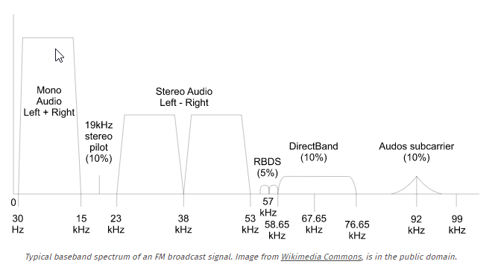

Channel width FM broadcast is 200Khz

Bandwidth is in 200Khz

We're only going to work with the mono audio channel. we need to pass it through a de-emphasis filter (this is to compensate for an analogous emphasis filter That was applied to the data at the transmitter.) we'll also need to decimate the signal down to the standard audio sampling rate (roughly 44.1-48 kHz). Finally, we will be able to write our audio data to a file and play it back.

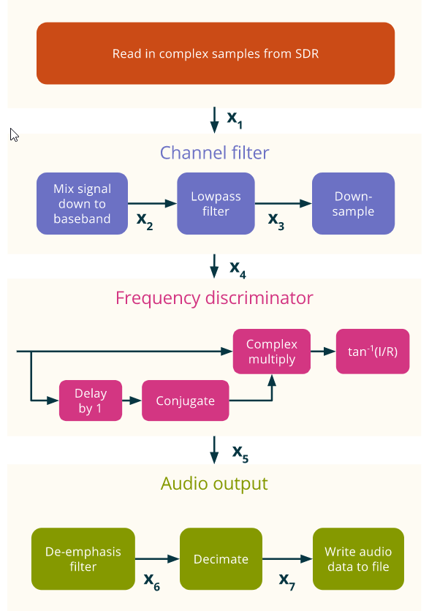

Input sample rate = 25MPS / 48 samples per second = 520,833 KSPS